Task #3: Creating a Blog: Your EOTM teacher Journal
Monday Morning, February 5th.
_________________________________________________________________
Purpose: The Blog will be one of the principle tools used by students to share ideas and receive feedback. To that effect, we will use this tool as a diary for your time here. In this activity, you will learn how to create a blog, place it in a folder and upload a picture.
_________________________________________________________________

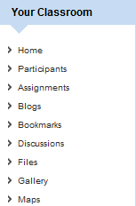
Step #1: Under Your Classroom, click on Blogs

Step #2: Selet Post a Blog
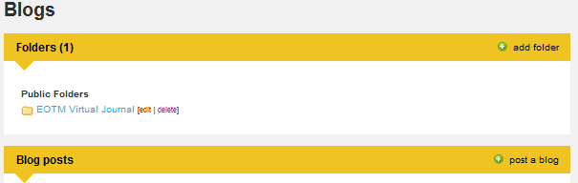

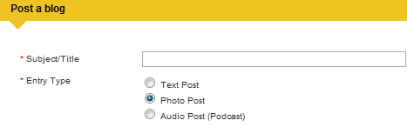
Step #3: Give your Blog a title and select Photo Post

Step #4: To Upload a picture, select Choose File
-Make sure your picture is not more than 300kb and is a JPG, PNG OR GIF
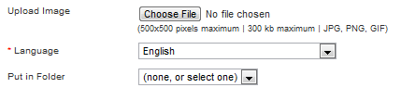

Step #5: To choose a Folder, select the down arrow (Folders are useful for organing the blogs

Step #6: To Post your Blog, go to the bottom and click Post!

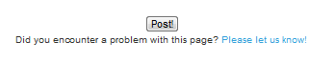

Congratulations, you have now posted your first EOTM Blog!!

