Task #1: Creating Your Profile
Monday Morning, February 5th.
______________________________________________________________
Purpose: To create profile on the TIG virtual classroom, so that all participants can get to know each other.
______________________________________________________________
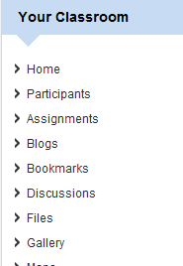
Step #1: Under, Your Classroom, click on Participants.
Step #2: Select your last name from the list

Step #3: Select edit profile on the right of the screen


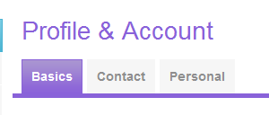
Step #4: Fill in as much information as you feel comfortable on top level tabs:

Step #5: Under My Accout fill in two catagories, About Me and Picture and Avatar

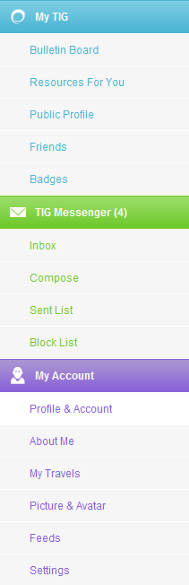

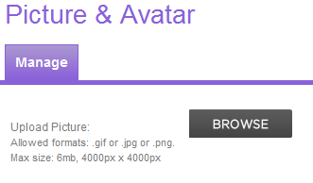
Step #6: Upload a picture. Click on browse and select picture.

