Task #2: Using Skydrive: Creating a Profile Questions
Monday Morning, February 5th.
_________________________________________________________________
Purpose: In order for participants to get to know one another and to use the TIG virtual page and Skydrive, each teacher is going to create two questions about themselves. These questions will be used in a “Profile Hunt” tomorrow
_________________________________________________________________

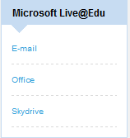
Step #1: Scroll down and under Microsoft Live@Edu, click on Skydrive

Step #2: You will be redirected to the Microsoft Skydrive page. Sign in using:
Username: Skydrive username (TIG name@tigweb.org) and password

Step #3: Fill in your year of birth, country and press I accept.
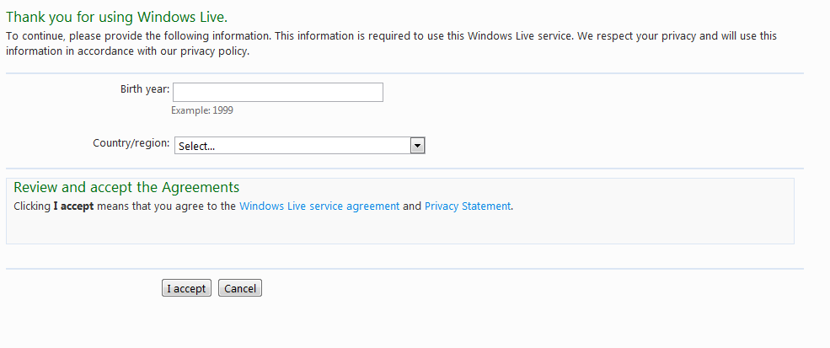
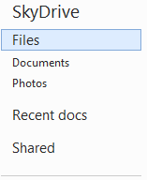
Step #4: Select Shared

Step #5: Select EOTM Profile Hunt and Follow Instructions

Step #6: Make sure that you save after entering your two questions

Congratulations you have now used MS Skydrive!!

